1. **Arduino UNO platform ---- IR_control**

****! ! Note:****

****1. In order to avoid the interference of sunlight on the infrared sensor, this experiment needs to be carried out indoors.****

****2. In the infrared remote control experiment, there is a row of pins above the 51 core board on the expansion board, and the right two pin headers should be equipped with a jumper cap, as shown in the figure below.****

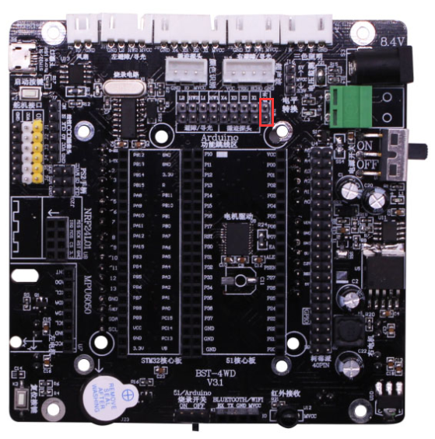

****3.We need to unplug the small fan and grayscale modules.****

**4. During remote control, the infrared remote control needs to face the infrared receiver on the expansion board.**

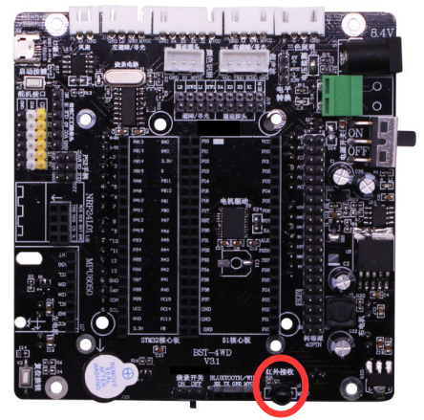

1. **Preparation**

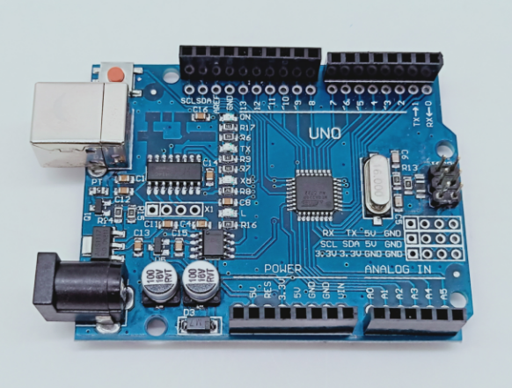

1-1 Arduino UNO board

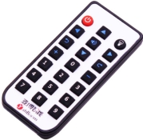 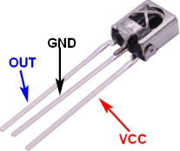

1-2 infrared remote control 1-3 infrared receiver

**2)Purpose of Experimental**

In this experiment, we used infrared remote communication to control the movement of the car.

**3)Principle of experimental**

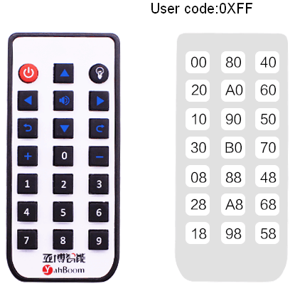

The infrared remote control receiving data is 00FFCMD (CMD inverted code).

All key corresponding coding value as shown below:

|  |  |
| --- | --- |
| 00FF00FF |  |
| 00FF30CF |  |
| 00FF708F |  |
| 00FF40BF |  |
| 00FFA05F |  |
| 00FF807F |  |
| 00FF20DF |  |
| 00FF609F |  |
| 00FF906F |  |
| 00FF10EF |  |
| 00FF50AF |  |
| 00FFB04F |  |
| 00FF08F7 |  |
| 00FF5877 |  |
| 00FF48B7 |  |
| 00FF28D7 |  |
| 00FFA857 |  |
| 00FF6897 |  |
| 00FF18E7 |  |
| 00FF9867 |  |
| 00FF58A7 |  |

The function defined by each button can be customized by modifying the program.

**4)Experimental Steps**

4-1 About the schematic

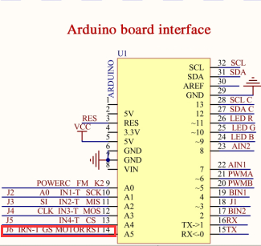

4-1 Arduino UNO interface circuit diagram 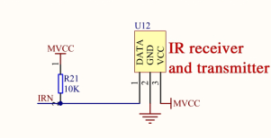

4-2 infrared receiver and transmitter

4-2 According to the circuit schematic:

IRN-----A5(Arduino UNO)

4-3 About the code

1. We need to open the code of this experiment: **IR_player_mode.ino** or **IR.ino**, click“**√**” under the menu bar to compile the code, and wait for the word "**Done compiling** " in the lower right corner, as shown in the figure below.

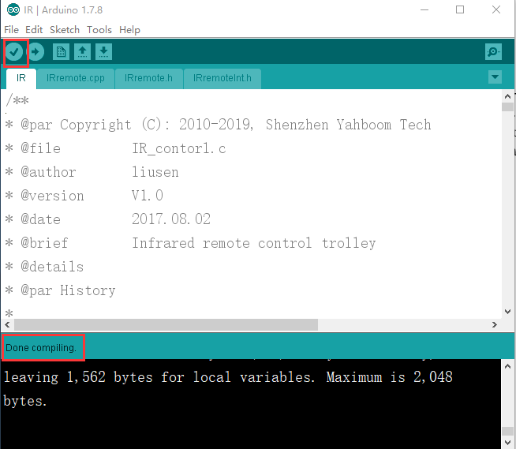

2.In the menu bar of Arduino IDE, we need to select 【Tools】---【Port】--- selecting the port that the serial number displayed by the device manager just now, as shown in the figure below.

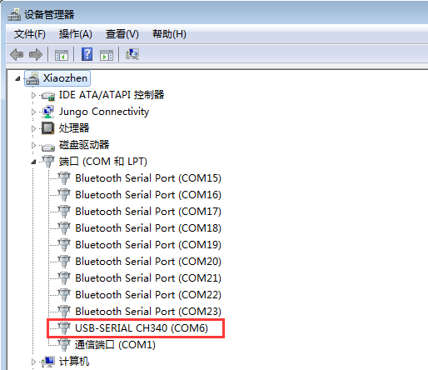

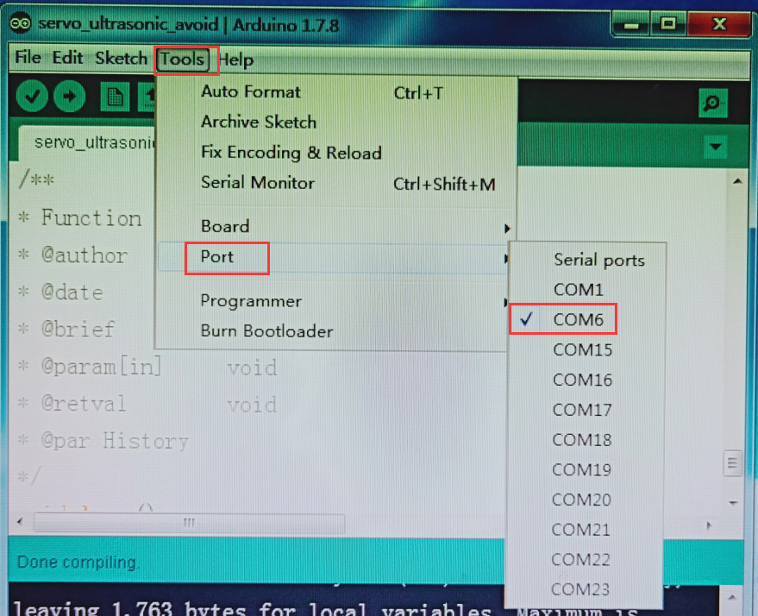

3.After the selection is completed, you need to click “**→**”under the menu bar to upload the code to the Arduino UNO board. When the word “**Done uploading**” appears in the lower left corner, the code has been successfully uploaded to the Arduino UNO board, as shown in the figure below.

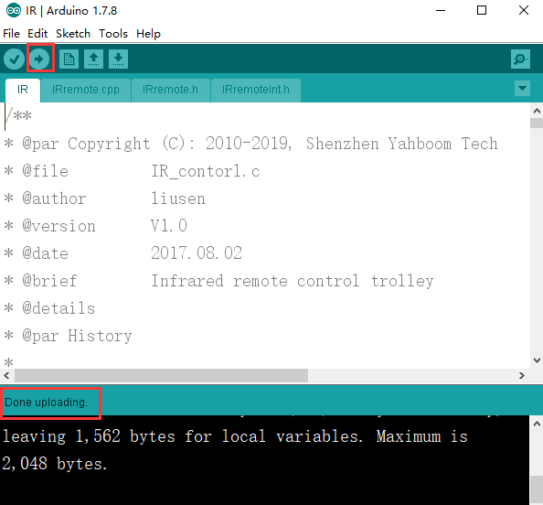

The following functions are controlled by the infrared remote controller:

**About IR.ino code:**

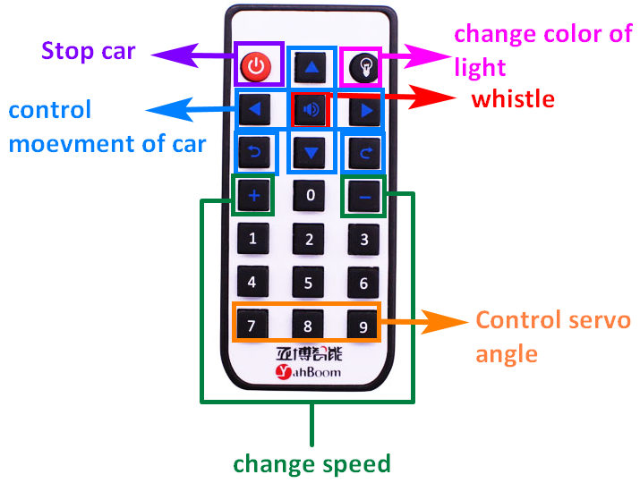

**About IR_player_mode.ino:**

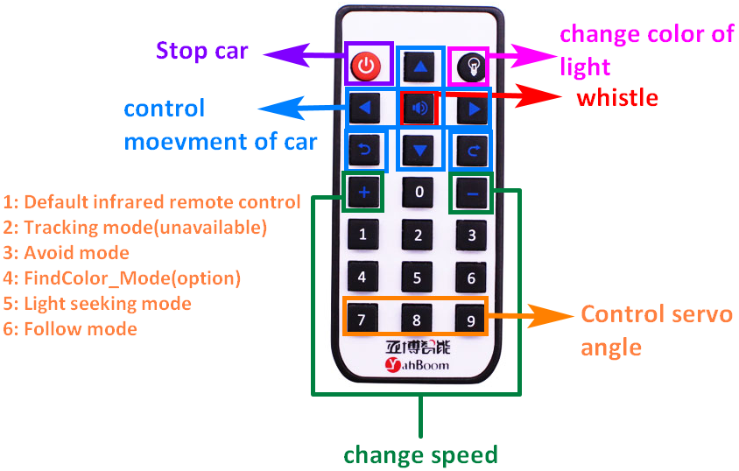

**!Note: Find color mode need to color track, please purchase additional.**